**Intelligent design script of permanent magnet brushless motor based on python and Taguchi method**

**Author: Zheng Shuchun**

**Contact: 17350545062@163.com**

**Keywords:** optimization, Taguchi method, python, permanent magnet brushless, single phase, three phase, intelligent

**Abstract:** This article introduces the intelligent design script of permanent magnet brushless motor based on python and Taguchi method. It is divided into five parts to show the project background, program flow chart, calculation results examples, conclusions and references of the project.

**Foreword:**

In order to avoid the fancy and useless concept hype and purposeful falsification of the prevailing journal papers, and to take into account the current popularity of the Internet and the knowledge, meanwhile the urgent need for technological advancement, and the journal platform, due to its closed nature, can no longer satisfy the display of nowadays fast-changing scientific achievements, and it has become synonymous with the new capital class wrapped in science skin. For the purpose of practical industrial applications, this article is divided into five parts to show the project background, program flow chart, calculation results examples, conclusions and references, and published in the online communities and social medium, hoping to speed up the dissemination and exchange of scientific and technological achievements. Due to my limited level, please forgive me for any shortcomings and welcome corrections and exchanges.

**Project background**

In September 2020, due to the needs of the project and the suggestions of my director, I started to code the motor optimization script based on Taguchi method. At the beginning, it was written in VBscript. Later, with the improvement of the project and the superiority of python, the source code of the project was transferred to the python platform.

The project is designed to optimize the performance of permanent magnet DC motors for single phase and three phase brushless external rotor fans. When selecting the optimization algorithm model, it is considered that the motor optimization is not a continuous function single extreme optimization, but a discrete space multi-objective optimization. In addition, the calculation of motor performance is based on finite element simulation, so the calculation time is longer, and the optimization algorithm model that requires more iterations such as genetic algorithm is excluded first.

For multi-objective optimization in discrete space, especially in complex environment and large amount of calculation, it is very important to analyze the influence degree of the optimization factors on the corresponding calculation results. Therefore, Taguchi optimization method is chosen to analyze the influence degree of the influence factors on the results and calculate the corresponding mean value.

The motor performance finite element analysis uses the API interface of the existing finite element analysis. The work done by my optimization script is to use Taguchi optimization method to generate the calculation raw data, and then feed the data to the finite element analysis software to analyze and obtain the performance calculation results, and then The result data is combined with the original data for Taguchi method analysis. According to the analysis results, select the optimized original data for the next round of calculation, and then repeat the above operations. Under normal conditions, the script can obtain the global optimal solution (the solution space is the engineering allowable space) within 50 calculations.

**Program flow chart**

1、Overall flow chart

Three phase

Single phase

Boundary selection, factor selection, other parameter settings

Output result

Calculation start

2、Subdivision flow chart

Need to calculate factors

Factor level division

Variation factor

Generate Orthogonal Table

Feed to finite element simulation

The optimization results are not up to standard and mutated

Output simulation calculation results

Input as optimized data

Taguchi method analysis to select the best combination

The calculation data is stored in the database

Calculate performance curve

Select the top 10 best solutions

Draw the curves

**Examples of calculation results**

1. Examples of intelligent calculation results for single phase brushless DC motors
2. The factors to be adjusted are shown in the following table.

The judgment index is: the greater the efficiency, the better,

the torque is 6 mN.m, and the cogging torque is less than 4 mN.m.

|  |  |
| --- | --- |
| Number of turns | 70 |
| Thick iron shell | 0.8 |
| Tooth width | 2.9 |
| Air gap | 0.4 |
| Slot full rate | 0.4 |
| Polar arc coefficient | 166 |
| Lead angle | 30 |
| Peak current | 0.5 |
| Magnet thickness | 3.1 |
| Notch width | 2.6 |
| Groove top depth | 1.2 |
| Fillet at the bottom of the groove | 0.8 |
| Groove tip fillet | 0.4 |
| Groove depth | 6.8 |
| Fixed rotor outer diameter | 41.1 |
| Stator inner diameter | 10 |
| Number of pole pairs | 2 |
| Addendum thickness medium factor | 1.1 |
| Coefficient of tooth tip thickness | 1.6 |
| Large outer diameter sink | 0.36 |
| Coefficient of outer diameter sinking | 0.45 |
| Groove top fillet | 0.8 |

3. Optimized result. The factor level division interval is 10%, the coefficient of variation is 50%, and the number of calculations is 11 times.

Efficiency-current curve Torque-current curve Cogging torque-current curve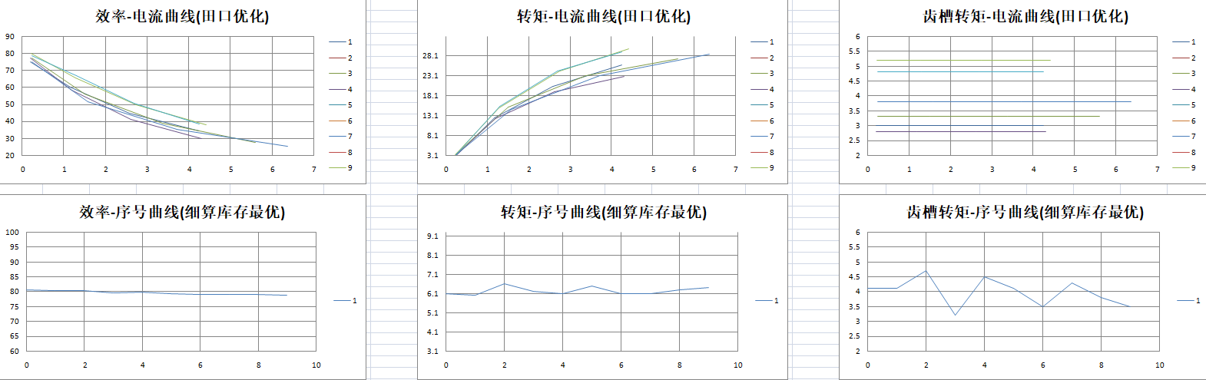

Efficiency- number curve Torque- number curve Cogging torque- number curve

**Examples of intelligent calculation results for three-phase brushless DC motors**

1. The factors to be adjusted are shown in the table below.

The judgment index is: the greater the efficiency, the better,

the torque is 45 mN.m, and the cogging torque is less than 15 mN.m.

|  |  |  |  |
| --- | --- | --- | --- |
| Number of turns | Polar arc coefficient | Lead angle | Peak current |
| 55 | 166 | 6.9 | 1 |

2. Optimized result. The factor level division interval is 20%, the coefficient of variation is 50%, and the number of calculations is 3 times.

Efficiency-current curve Torque-current curve Cogging torque-current curve

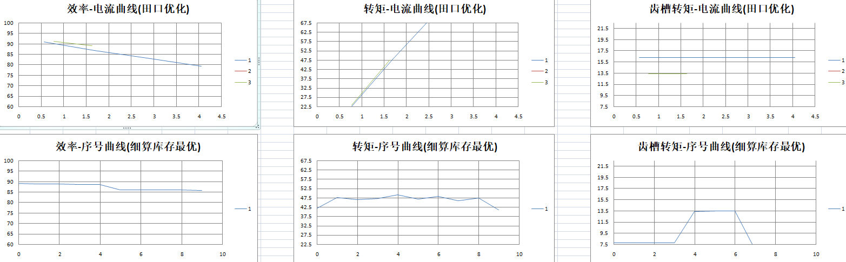

Efficiency- number curve Torque- number curve Cogging torque- number curve

**Conclusion**

Combining the database, Taguchi method and motor finite element analysis through python can realize the intelligence and automation of motor performance calculation. This program of mine can realize the intelligence of motor design, and can automatically store the calculation results and parameters. With the time used by the script accumulating and the inventory data increasing, the more likely the inventory data has already had an optimal solution, the fewer calculations will be needed to optimize motor performance in the future.

The time consumed for a single calculation is:

1. The number of factors is less than 5, 10 minutes;

2. 5<=number of factors<14, 20 minutes;

3. 14<=number of factors<26, 40 minutes;

4. 26<=number of factors<=31, 40 minutes;

The fewer optimization factors, the less calculation times the script needs to obtain the global optimal solution, even if there are too many factors, in most cases only 50 calculations or less are required to obtain the global optimal solution (appropriate factor level division ).

**References**

The reference materials in this article are the literature works of all the predecessors and pioneers at home and abroad who have made contributions in the field of electrical machinery, optimization, intelligence, programming and database.